# **Pay Per Clicks in 2023**

Misc Archive is a digital marketing agency in Trivandrum that specialises in providing cheap and high-quality digital marketing services to all kinds of businesses. We work with businesses of all sizes to develop customised digital marketing solutions that help them reach their goals. Our team of experts is always looking for ways to get your business in front of the right people and drive traffic to your website. One of the ways we do this is by setting up a Pay Per Click (PPC) campaign using Google Ads. Pay Per Click (PPC) campaigns using Google Ads are one of the most powerful tools available for quickly getting your business in front of potential customers.

## **What are Pay Per Click Ads?**

Pay Per Click (PPC) ads are online advertisements that appear on search engine results pages (SERPs) when someone searches for specific keywords. These ads are typically placed at the top of the page and are labelled "Sponsored" or "Ad." When someone clicks on the ad, they are directed to the advertiser’s website, and the advertiser pays the search engine for the click.

PPC ads are an effective way to drive targeted traffic to your website and increase your brand's visibility. With PPC, you can target users based on location, interests, and other criteria. This helps you reach the right people at the right time, which can lead to more conversions. This in turn means that you can customise your campaigns to make sure that you’re spending your budget on the users that are most likely to convert

### The importance of Google Ads

* Google Ads is one of the most popular PPC platforms, and it offers many advantages. It's easy to set up and manage campaigns, and there is a variety of targeting options available. Google Ads also has powerful analytics that allows you to track the performance of your campaigns in real-time, so you can make adjustments as needed.
* Google AdWords are also inexpensive. You can set a daily budget and only pay when someone clicks on your ad. This means you won’t waste money on ads that don’t generate clicks. You can also set different bids for different keywords, so you can control how much you pay for each click. Google ads are highly targeted as well. You can target users based on their location, interests, and other criteria, so you can reach the right people at the right time. This can help you get more clicks, more conversions, and a higher ROI.
* Google AdWords is also an excellent tool for testing. You can run multiple campaigns at once to see which one performs best. This allows you to optimise your campaigns and get the most out of your budget.
* Finally, Google Ads is highly scalable. You can easily increase or decrease your budget as needed to reach your goals. This makes it easy to adjust your campaigns as your business grows.

## **Types of PPC**

With PPC, businesses can create targeted ads and only pay when someone clicks on them. There are several types of PPC ads, each with its own advantages and disadvantages. Different types of PPC Ads.

### Search Ads

Search ads, also known as paid search or sponsored search ads, appear at the top of search engine results pages (SERPs) when someone searches for a specific keyword or phrase. These ads are text-based and typically include a headline, a short description, and a clickable link to a landing page.

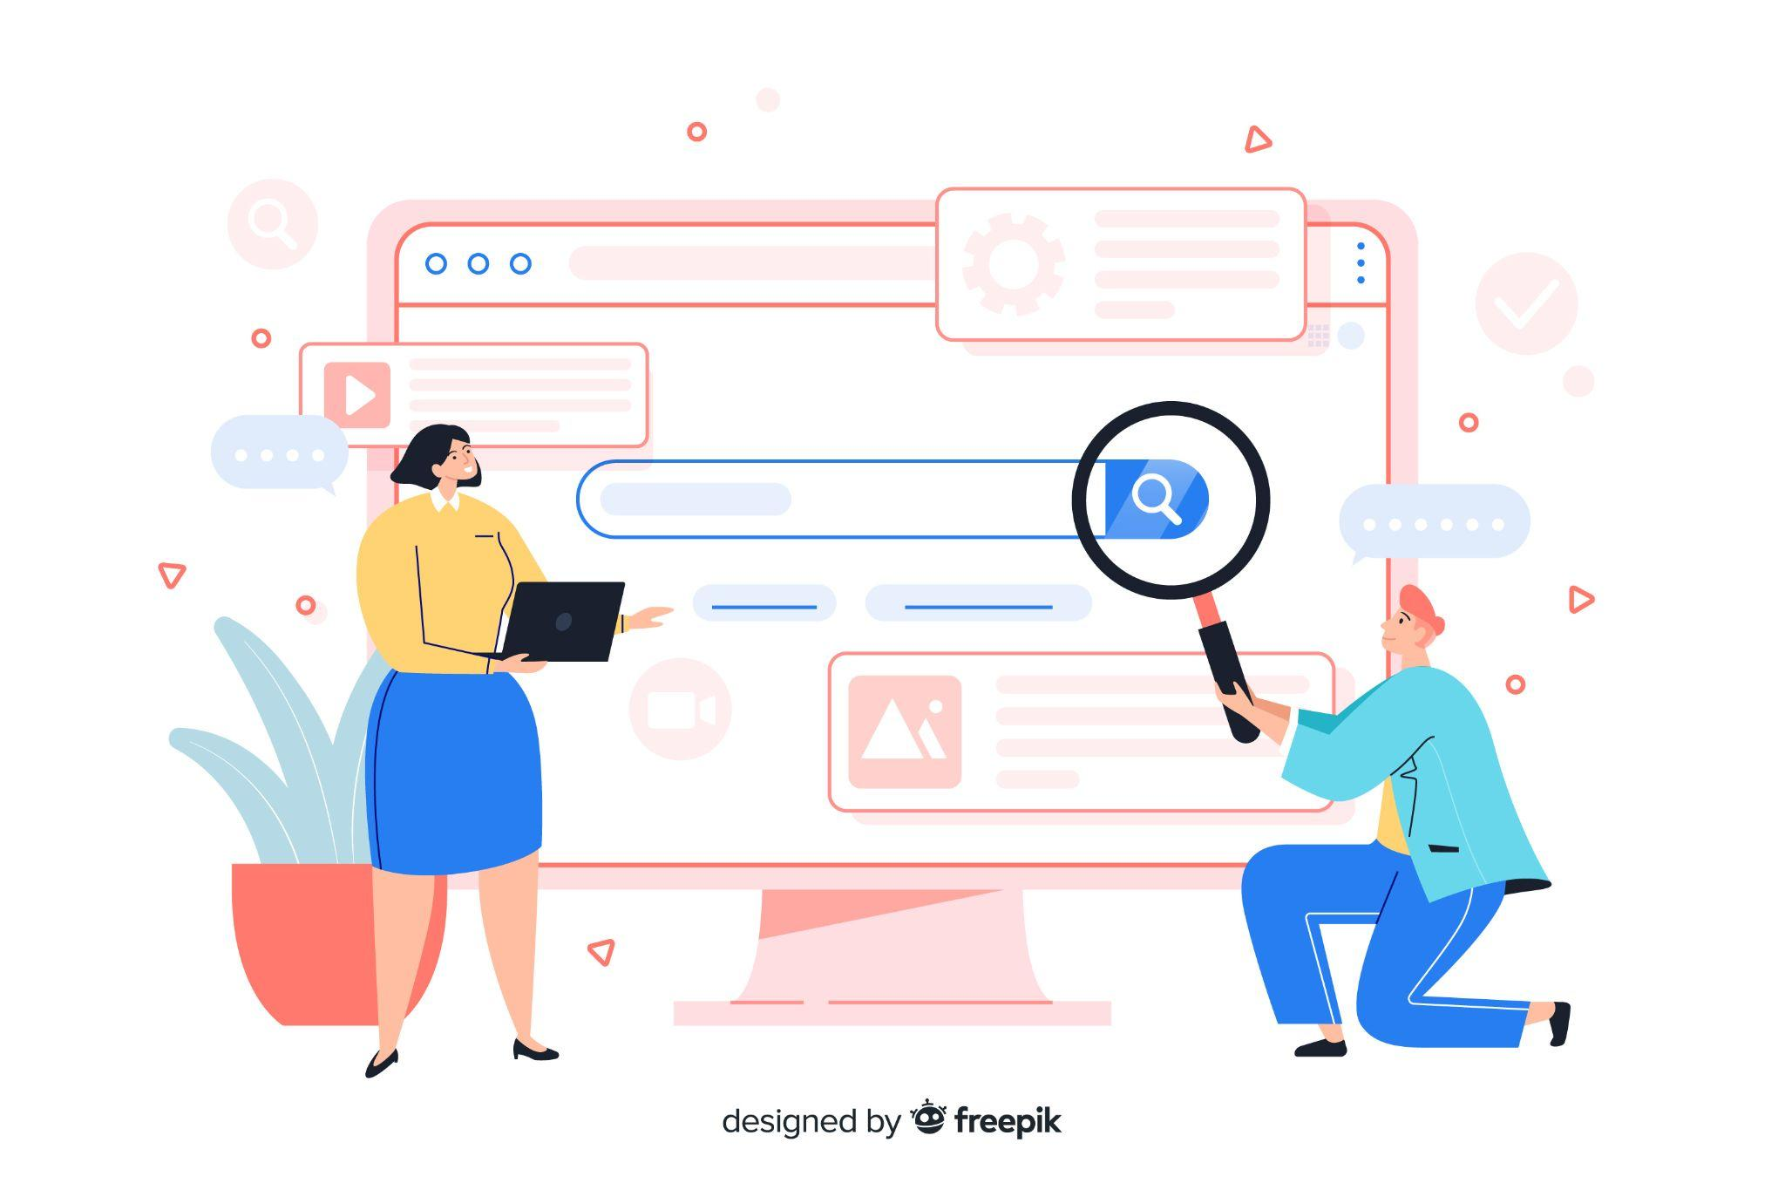

Search ads are highly targeted and effective because they appear when people are actively searching for a product or service. Advertisers can set specific keywords and bid on them to determine their ad's placement in the search results.

### Display Ads

Display ads are visual ads that appear on websites and apps that have partnered with advertising networks like Google AdWords. These ads can be in the form of images, videos, or interactive ads. Display ads are less targeted than search ads, but they can be useful for building brand awareness and generating leads.



Advertisers can choose specific websites or demographics to target with their display ads. They can also use retargeting to show ads to people who have previously interacted with their website or ads.

### Social Media Ads

Social media ads are paid ads that appear on social media platforms like Facebook, Instagram, Twitter, and LinkedIn. These ads can be in the form of images, videos, or carousels. Social media ads are highly targeted, and advertisers can choose specific demographics, interests, behaviours, and locations to target.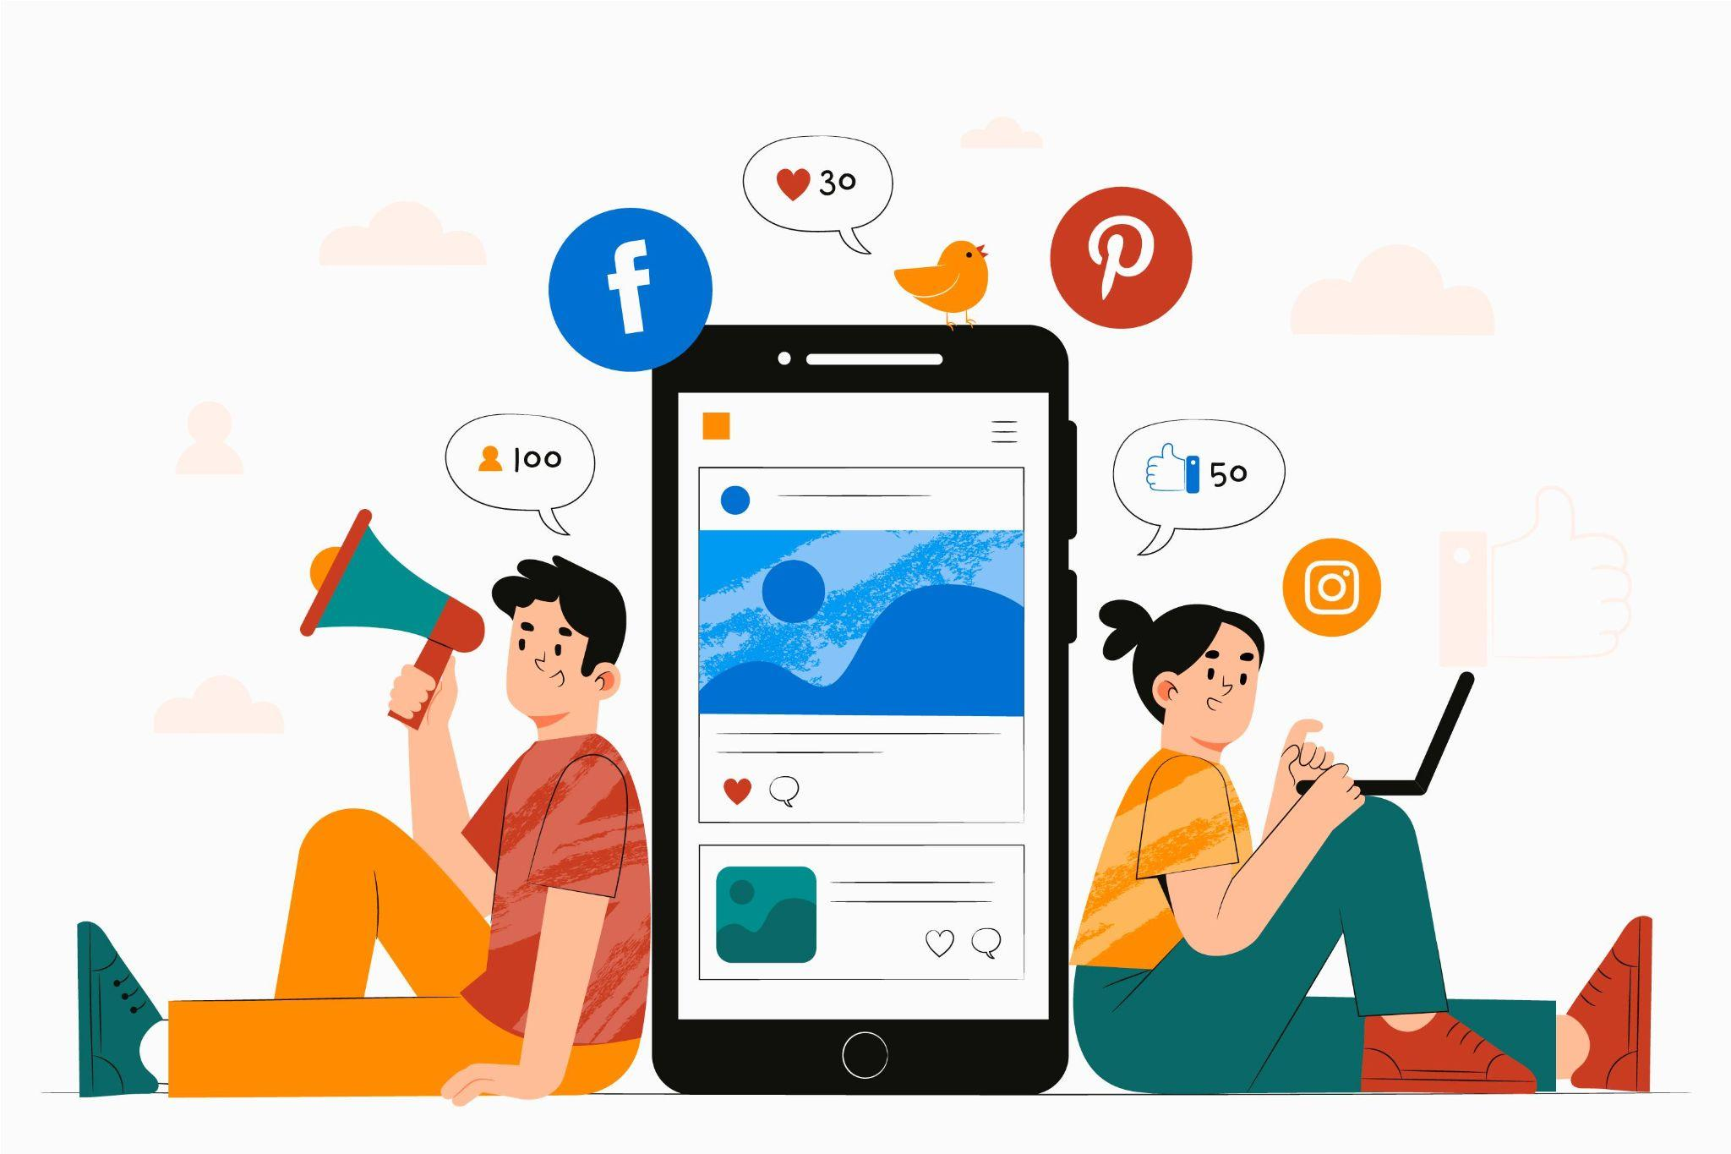

Social media ads can be effective for building brand awareness, generating leads, and driving website traffic. They can also be used for retargeting people who have previously interacted with a business's social media or website.

### 

### 

### 

### 

### Shopping Ads

Shopping ads, also known as product listing ads (PLAs), appear at the top of search engine results pages when someone searches for a specific product. These ads include an image of the product, its price, and a clickable link to the product page on the advertiser's website.

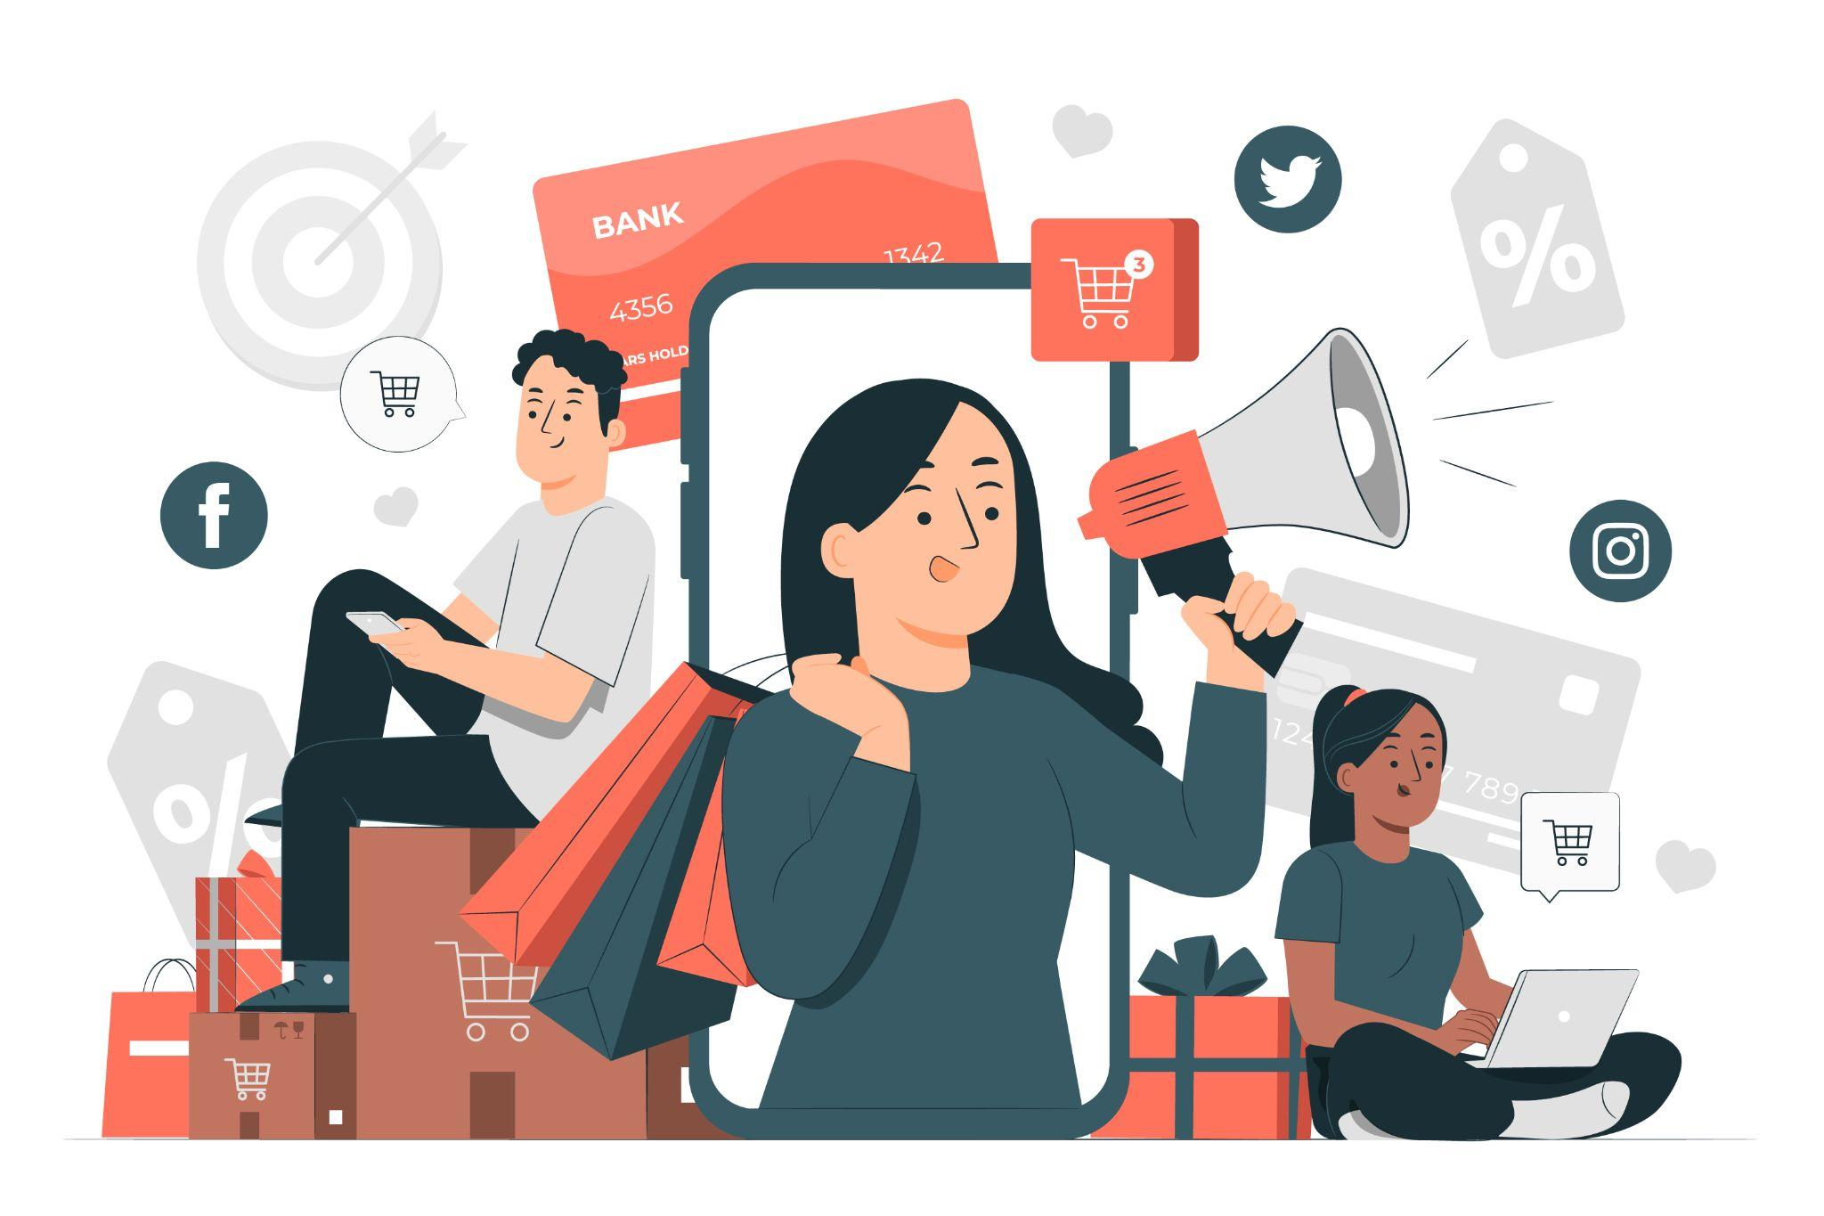

Shopping ads are highly effective for e-commerce businesses because they allow them to showcase their products to people who are actively searching for them. Advertisers can use Google Shopping to create and manage their shopping ads.

In conclusion, there are several types of PPC ads that businesses can use to reach potential customers. Search ads are highly targeted and effective for reaching people who are actively searching for a product or service. Display ads are useful for building brand awareness and generating leads. Social media ads are highly targeted and effective for reaching specific demographics, interests, behaviours, and locations. Shopping ads are highly effective for e-commerce businesses because they allow them to showcase their products to people who are actively searching for them. By understanding the different types of PPC ads, businesses can create effective ad campaigns that reach their target audience and generate results.

## **Contact Us Now**

At Misc Archive, we understand the importance of local online marketing and Google Ads. We have a team of experts who can help you set up and manage your campaigns. We offer customised packages that are tailored to your business goals and budget.

If you’re ready to take your digital marketing to the next level, contact us now to get a customised package for your business.